
Alumis announces topline data from the Ph3 ONWARD
program in moderate-to-severe PsO

Company: Alumis Inc.  Drug: envudeucitinib (ESK-001) | Date: 06.01.2026  Source(s): Alumis press release; webcast; presentation
What happened:
- Alumis announced topline results from the pivotal Ph3 ONWARD-1 and ONWARD-2 trials evaluating envudeucitinib (ESK-001, oral TYK2 inhibitor) in adults with moderate-to-severe plaque psoriasis (PsO)
- Both trials met all primary and key secondary endpoints, with 74% of patients achieving PASI 75 and 59% achieving sPGA 0/1 at Week 16, and ~ 65% achieving PASI 90 and >40% achieving PASI 100 at Week 24. Data from placebo and apremilast (Otezla) arms not disclosed
- Company noted rapid onset with PASI 90 separation from placebo as early as Week 4, and clinically meaningful improvements in PROs (Quality of Life and itch)
- Envudeucitinib was generally well tolerated; safety was consistent with Ph2 STRIDE and open-label extension (OLE) studies
- Alumis intends to submit a New Drug Application (NDA) to the FDA in H2 2026

Impact (CI PoV): HIGH
- Envudeucitinib represents an addition to the oral TYK2 inhibitor class in PsO, with efficacy and safety data supporting its relevance as oral systemic option
- CI anticipates regulatory submissions in Q3 2026, with FDA approval in Q3 2027 and EC marketing authorization expected in Q2 2027 (no company guidance on EU submission)

Why it matters:
- Envudeucitinib adds to the growing list of oral TYK2 inhibitors demonstrating late-stage efficacy in moderate-to-severe PsO
- Alumis differentiates envudeucitinib from other TYK2i as “a precision engineered oral TYK2i with maximal target inhibition” that “translates to leading efficacy with balanced safety and tolerability”
- The company positioned envudeucitinib as addressing unmet needs within the oral TYK2 inhibitor space and characterized the asset as “best-in-class" in comparison with approved oral agents such as Sotyktu (deucravacitinib) and Otezla (apremilast), while comparing PASI outcomes versus Sotyktu and icotrokinra (slide below)
  - Recall, Takeda reported Ph3 PsO data for zasocitinib (TAK-279), a key oral TYK2 competitor, in Dec 2025, including PASI 90 (>50%) and PASI 100 (30%) responses at Week 16

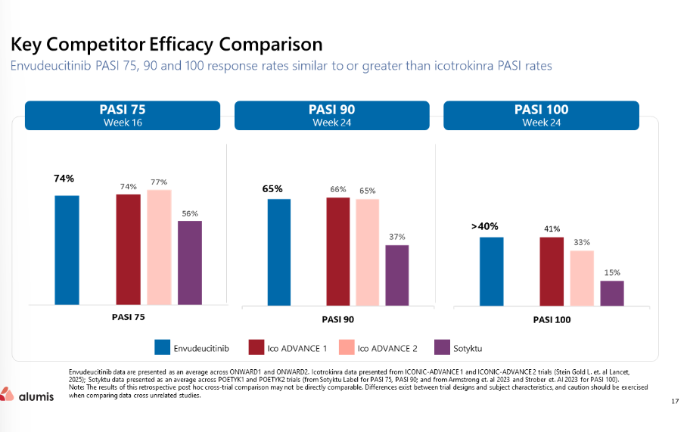
Data are a cross-trial comparison

- Alumis also highlighted broader ambitions for TYK2 inhibition beyond PsO, citing ongoing Ph2b development of envudeucitinib in systemic lupus erythematosus (SLE) in the LUMUS study

Tell me more:
- Study Design: ONWARD-1 and ONWARD-2 are placebo-controlled, 2:1:1 randomized Ph3 trials evaluating the efficacy and safety of oral ESK-001 in adult patients (N=840) with moderate-to-severe plaque psoriasis administered as a twice-daily 40 mg dose through Week 24 versus placebo till W16 (prior switch to ESK-001) and 30 mg apremilast through W24
- Endpoints:
  - Co-primary endpoints: PASI 75 and sPGA 0/1 at Week 16 versus placebo
  - Co-secondary endpoints: PASI 90, PASI 100, sPGA 0/1 and safety and tolerability through Week 24
  - Patient-reported outcomes including quality of life (QoL) and pruritus through Week 24
- Both ONWARD trials met all primary and key secondary endpoints with high statistical significance
- Placebo-adjusted response rates for the co-primary endpoints were reported to be consistent across both studies
- Management noted during Q&A that placebo-adjusted response rates were presented to account for variability in placebo PASI 75 responses observed across the ONWARD studies

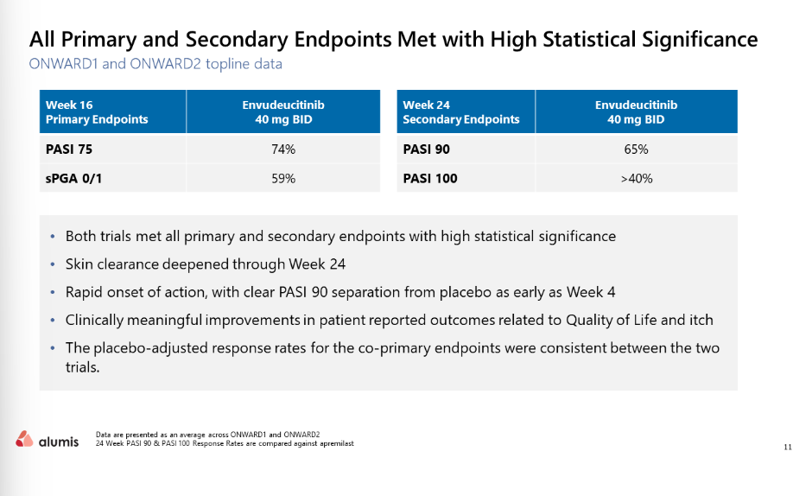

- Safety:
- ESK-001 was generally well tolerated through Week 24 with majority of TEAEs being mild to moderate and responding to standard therapy
- Common TEAEs included headaches, nasopharyngitis, upper respiratory tract infection and acne
- Discontinuations due to adverse effects were reported to be low

- Messaging:
  - Alumis described envudeucitinib as a “next-generation” oral TYK2 inhibitor and positioned the asset as a core component of its broader pipeline strategy

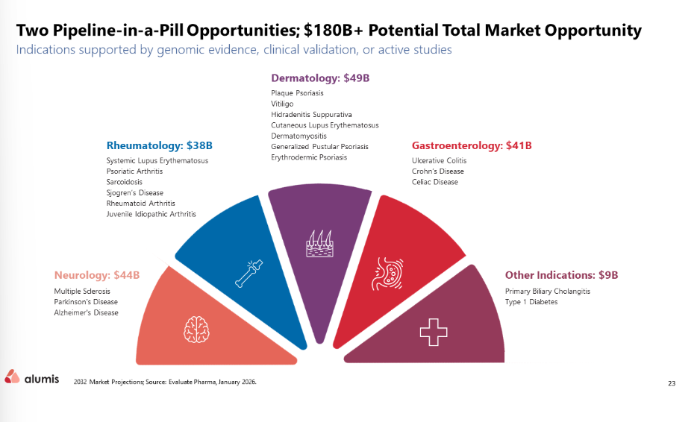

- Future catalysts:
  - Additional secondary and exploratory endpoints from the ONWARD Ph3 program are expected to be presented at future medical meetings in 2026
    - CI expects potential data readouts at AAD and EADV 2026
  - The Ph2b LUMUS study evaluating envudeucitinib in SLE remains ongoing, with topline data expected in Q3 2026
- Alumis management remained confident that TYK2 inhibition could demonstrate higher efficacy in SLE within a less saturated oral market
  - ONWARD-3, a long-term OLE study assessing durability of response and long-term safety in moderate-to-severe PsO, is currently recruiting, with primary completion expected in Nov 2028; a Ph2 OLE study of ESK-001 in PsO is expected to complete in Q4 2026, Ph2 2-year data expected in H2 2026
  - Alumis noted that evaluation of a once-daily formulation of envudeucitinib remains ongoing; however, no further timelines or updates were disclosed

Other key slides:

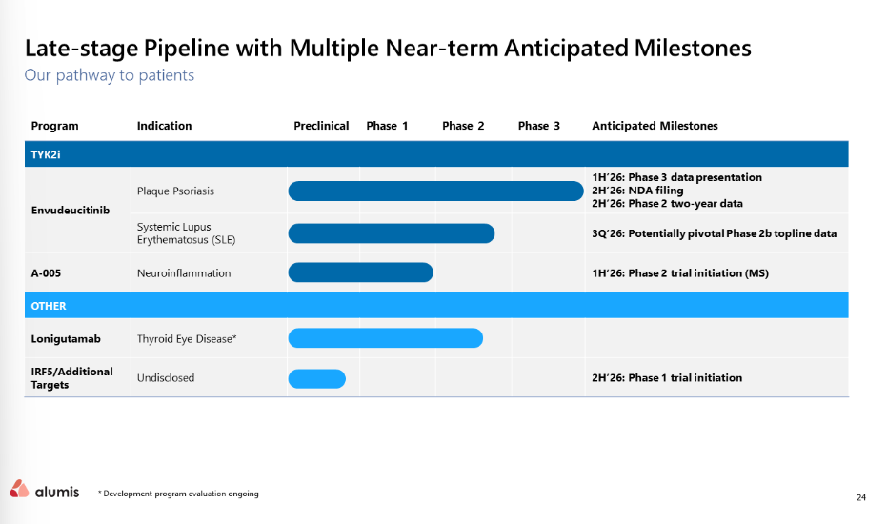

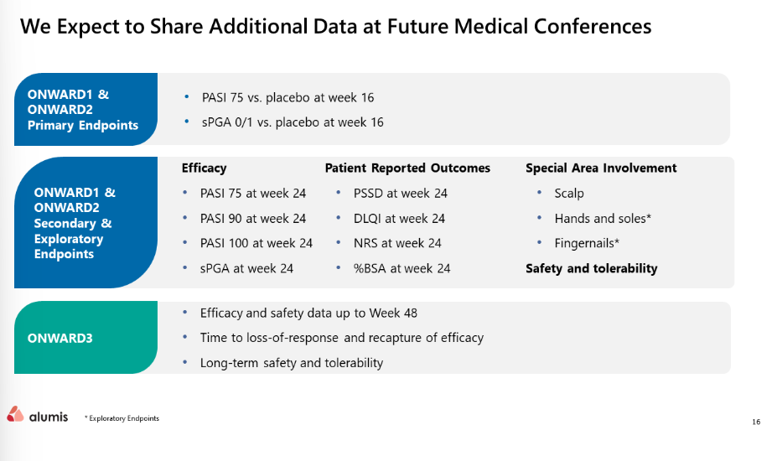

For questions, please reach out to:
International / Affiliates: Priti Anand, Irene Knorn
US: Chanda Bhat, Bethany Christmann
PCS: Luke Versten

Invite your colleagues to inVision | Manage Email Preferences | Unsubscribe

This document/email contains competitive intelligence collected via an approved competitive intelligence supplier working on behalf of AbbVie. We collect competitive intelligence consistent with industry standards and AbbVie policy. Not for field distribution. Please reach out to APEX/IMABI, Legal, or OEC teams with any questions.

